Greek handwriting

from www.FarAboveAll.com

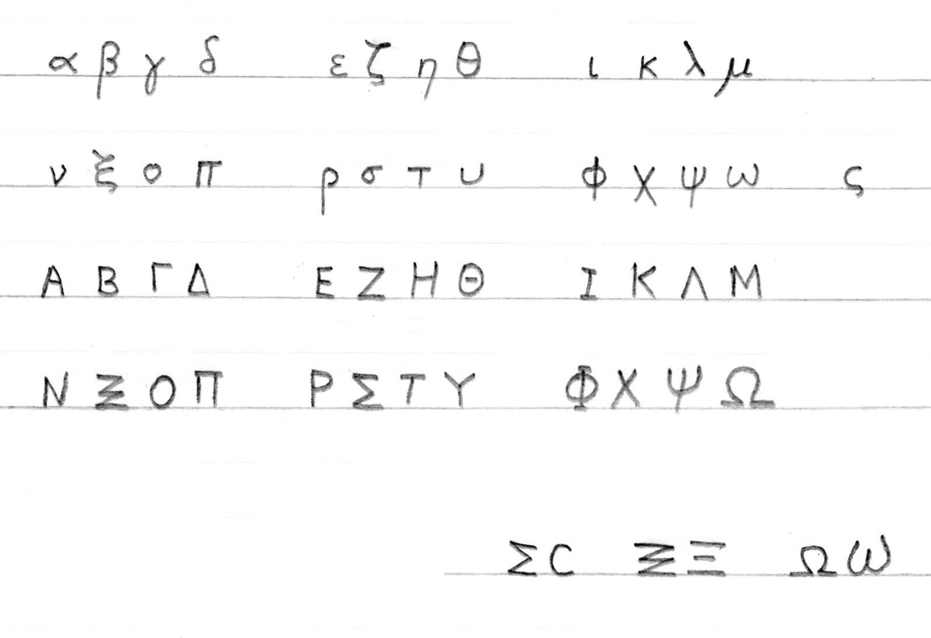

Alternative capitals

