Verification of Burgon's Patristic Evidence for Reading Θεός in 1 Timothy 3:16.

Graham G. Thomason, 10th April 2019
Revised, 18th March 2023
www.FarAboveAll.com

Introduction
When the Revised Version of the Bible was published in 1881, Dean John William Burgon reviewed it, and the new Greek text on which it was based, and saw that it was very much a corrupt and watered-down version of Scripture. He provided a mass of ancient evidence supporting traditional readings – in other words the Majority Text. His defence of 1 Timothy 3:16, God was manifested in the flesh, (where the Revisers have replaced God by he), can be found in his book Revision Revised, which we hereafter refer to as [Burgon-RR], pages 424-520. Where the context makes the reference to this book obvious, we may simply refer to a page number.

In other studies available on www.FarAboveAll.com we discuss the manuscript and lectionary evidence, which, thanks to the availability of scans online, hosted by INTF and CSNTM, we have been able to verify (finding very few exceptions and anomalies), and to greatly extend. Verification of Burgon's patristic evidence (otherwise known as Church Father evidence), which seemed daunting in the past, has become easier in recent years, thanks to online resources such as www.archive.org.

We first consider the six “primitive witnesses” cited on pages 463-464 of [Burgon-RR]. Burgon does not build on these witnesses, but they are very suggestive. Then we consider the patristic witnesses on “terra firma” in the order summarized on pages 485 - 490, noting that more details are discussed in a different order in Burgon's preceding pages.

1 Timothy 3:16, in the text we are validating in this article, reads
Καὶ ὁμολογουμένως μέγα ἐστὶν τὸ τῆς εὐσεβείας μυστήριον· θεὸς ἐφανερώθη ἐν σαρκί, ἐδικαιώθη ἐν πνεύματι, ὤφθη ἀγγέλοις, ἐκηρύχθη ἐν ἔθνεσιν, ἐπιστεύθη ἐν κόσμῳ, ἀνελήφθη ἐν δόξῃ.
and confessedly great, is the mystery of godliness: God was manifested in the flesh, justified in the spirit, seen by angels, preached among the Gentiles, believed on in the world and taken up in glory.

With even a little knowledge of Greek, the reader will recognize the text from printed works when quoted as above. Allowance must be made for a few differences in orthography when reading old printed works, which mimic to some extent the great variety of digraphs and stylistic variations in manuscripts. But when the text of an ancient witness only carries the sense of the above, we transcribe it and give a translation.

All images are for personal use only. We have credited the digitizing sponsors. The images have been processed and reduced in resolution so as to make the size of this document manageable over the internet, whilst maintaining the same general level of legibility under normal reading circumstances.

The six “Primitive Witnesses” on pages 463-464 of [Burgon-RR]

- Ignatius, 1st century, [Burgon-RR, p. 463] - verified
The references can be verified online in Patres Apostolici, edited by Franciscus Xaverius Funk, Published by H Laupp, Tubingen, 1901. Ignatius' letter to the Ephesians, chapter 19, printed page 228, line 13. Digitizing sponsor: Google. Image for personal use only.
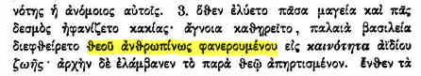
https://archive.org/details/patresapostolic00piongoog/page/n387
ἄγνοια καθῃρεῖτο, παλαιὰ βασιλέια διεφθείρετο θεοῦ ἀνθρωπίνως φανερουμένου εἰς καινότητα ἀϊδίου ζωῆς·
Ignorance was destroyed and the ancient realm was brought to ruin, when God became manifest in a human way, for the newness of eternal life.

Ignatius' letter to the Ephesians, chapter 7. Printed page 218, lines 18-19. Digitizing sponsor: Google. Image for personal use only.
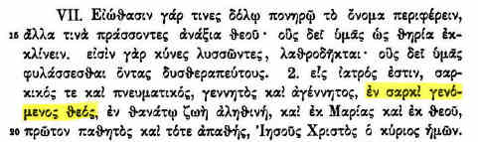
https://archive.org/details/patresapostolic00piongoog/page/n377
εἷς ἰατρός ἐστιν, σαρκικός τε καὶ πνευματικός γεννητὸς καὶ ἀγέννητος, ἐν σαρκὶ γενόμενος θεός, ἐν θανάτῳ ζωὴ ἀληθινή, καὶ ἐκ Μαρίας καὶ ἐκ θεοῦ, πρῶτον παθητὸς καὶ τότε ἀπαθής, ᾿Ιηθοῦς Χριστὸς ὁ κύριος ἡμων.
For there is but one physician, both fleshly and spiritual, born and unborn, God come in the flesh, true life in death, from both Mary and God, first subject to suffering and then beyond suffering, Jesus Christ our Lord.

Ignatius' letter to the Magnesians, chapter 8. Printed page 236, lines 14-15. There is a critical text issue, given below, which is not relevant to the reading we are contending. Digitizing sponsor: Google. Image for personal use only.
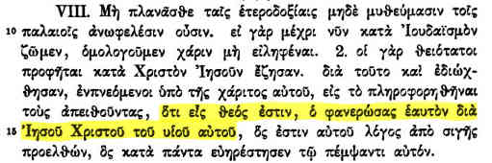
https://archive.org/details/patresapostolic00piongoog/page/n395
Critical apparatus note to λόγος:
ὅτι εἷς θεός ἐστιν ὁ φανερώσας ἑαυτὸν διὰ ᾿Ιηωοῦ Χριστοῦ τοῦ υἱοῦ αὐτοῦ, ὅς ἐστιν αὐτοῦ λόγος [ἀΐδιος οὐκ] ἀπὸ σιγῆς
that there is one God, who manifested himself through Jesus Christ his son, who is his [Word from silence / eternal Word not from silence]

The references can also be verified online in English in The Epistles of St. Ignatius, Bishop of Antioch, volume I, by Rev. J. H. Strawley, D.D., published by the Society for Promoting Christian Knowledge, London, 1910. Digitizing sponsor: MSN.

Chapter XIX, printed page 57, line 2:
https://archive.org/details/theepistlesofsti01srawuoft/page/56
God was appearing in human form

Chapter VII, printed page 47, line 2:
https://archive.org/details/theepistlesofsti01srawuoft/page/46
God in man

Chapter VIII, printed page 66, lines 1-2:
https://archive.org/details/theepistlesofsti01srawuoft/page/66
There is One God Who manifested Himself through Jesus Christ His Son

The three references given can also be verified offline in Greek and English from The Apostolic Fathers I, Loeb Classical Library; see our reference [Ignatius-L], shown below. The page numbers are 238/239, 226/227, and 248/249 respectively.

(b) Barnabas, 1st century, [Burgon-RR, p. 463] - verified
The reference can be verified online in Greek and English in ΒΑΡΝΑΒΑ ΕΠΙΣΤΟΛΗ, The Epistle of Barnabas, From the Sinaitic Manuscript of the Bible, with a Translation by Samuel Sharpe, published by Williams and Norgate, Edinburgh, 1880, chapter 12, printed pages 42 (English) and 43 (Greek), lines 1-2. We supply Greek accentuation below. Digitizing sponsor: Google. Image for personal use only.
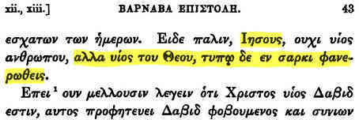
https://archive.org/details/epistlebarnabas00bookgoog/page/n71
Εἶδε [misspelling of Ἴδε] πάλιν ᾿Ιησοῦς, οὐχὶ υἰὸς ἀνθρώπου, ἀλλὰ υἰὸς τοῦ θεοῦ, τύπῳ δὲ ἐν σαρκὶ φανερωθείς.
Behold again, Jesus was not the son of man, but the son of God, who was by a figure made manifest in flesh.
We remark that the English relative pronoun (a participle in the Greek) who is in grammatical agreement with Jesus, not God. So the quotation, which Burgon only claims as suggestive (“is not insisted upon”), should not be taken out of context, (God ... made manifest in flesh). It is the combination manifest in flesh, and of God not of man, which suggestively links the citation to 1 Timothy 3:16.
The reference given can also be verified from The Apostolic Fathers II, Loeb Classical Library; see our reference [Barnabas-L]. For a discussion of the authorship of the epistle, see [Barnabas-L, pp. 5-8]. The date of authorship as given by various scholars ranges from 96 to 132 A.D.

From (The) Epistle of Barnabas, Chapter 12 [Barnabas-L, pp. 58/59 and 60/61]:
ἴδε πάλιν ᾿Ιησοῦς, οὐχὶ υἰὸς ἀνθρώπου, ἀλλὰ υἰὸς τοῦ θεοῦ, τύπῳ δὲ ἐν σαρκὶ φανερωθείς.
Again you see Jesus, not as son of man, but as Son of God, and manifest in the flesh as a type.

(c) Hippolytus of Rome, 2nd century, [Burgon-RR, p. 463] - verified
The reference can be verified online in Scriptorum Ecclesiasticorum Opuscula Praecipua Quaedam, (Certain Excellent Minor Works by Ecclesiastical Writers) edited by Martin(us) Joseph(us) Routh, Oxford, MDCCCXXXII (1832), Oxonii (Oxford), S. Hyppolyti, Contra Haeresin Noeti, page 72, lines 9-10. Digitizing sponsor: Google. Images for personal use only.
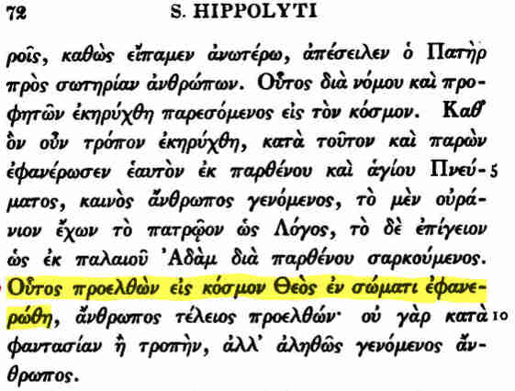
https://archive.org/details/scriptorumeccle00unkngoog/page/n90
Οὗτος προελθὼν εἰς κόσμον Θεὸς ἐν σώματι ἐφανερώθη
When He had come into the world, God was manifested in a body

Burgon's other Routh reference is on printed page 76, line 4 of the same book. Digitizing sponsor: Google. Images for personal use only.
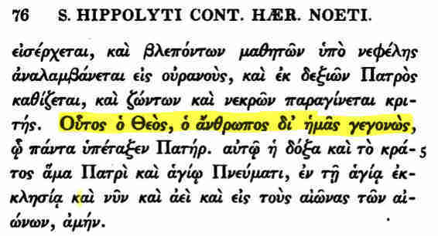
https://archive.org/details/scriptorumeccle00unkngoog/page/n94
Οὗτος ὁ Θεὸς, ὁ ἄνθρωπος δι' ἡμᾶς γεγονὼς,
He, God, having become man on our account

Theodoret's quotation of Hippolytus, in his “Dialogues”, can be verified in volume 83 of our reference [PatrGraec]. The columns, not pages, are numbered. Column 173, lines 41-42 (roughly opposite the number 133 in the Latin column). Digitizing sponsor: Google. Image for personal use only.
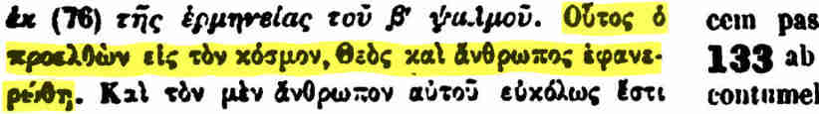
https://archive.org/stream/PatrologiaGraeca/Patrologia%20Graeca%20Vol.%20083#page/n91/mode/2up
Οὗτος ὁ προελθὼν εἰς κόσμον, Θεὸς καὶ ἄνθρωπος ἐφανερώθη
When He had come into the world He was manifested as God and Man

This citation can also be verified in English from Nicene and Post-Nicene Fathers of the Christian Church, volume II, our reference [S+W:2], with Theodoret translated by Rev. Blomfield Jackson.
https://archive.org/details/selectlibraryofn03scha/page/202
Printed page 202, at the end of column 2 and the start of the next page, or
http://mb-soft.com/believe/txub/theodor7.htm
Search in the document for “manifested as God and Man”.

N.B. By searching for the word “manifest”, various references to 1 Timothy 3:16 will be found, including the one attributed to Hippolytus, which Burgon quotes. The others must be ascribed to Theodoret.

(d) Gregory Thaumaturgus, 3rd century, quoted by Photius [Burgon-RR, p. 463] - manuscript not identified
Burgon's citation, with our English, is:
καὶ ἔστι Θεὸς ἀληθινὸς ὁ ἄσαρκος ἐν σαρκὶ φανερωθεὶς
And He is [the] true God, the unfleshly [one] having appeared in [the] flesh

If we understand Burgon's reference “Cod. 230,–p. 845, line 40” correctly, it is a specific Photius manuscript (230) which we cannot identify, then page 845 line 90. We searched for “Photius” on the Pinakes website, https://pinakes.irht.cnrs.fr/, using Recherche générale, which gives 975 results, of which 17 are in the United Kingdom (all are in London). One, Diktyon 39280, is given as Cod. 230 : scriptio inferior in uncialibus litteris, (lower writing of a palimpsest in uncial letters), but it is only one page. It is British Library Arundel 529. Arundel 529 can be viewed online at
https://www.bl.uk/manuscripts/Viewer.aspx?ref=arundel_ms_529_f032r. The lower writing is only apparent on one page, (folio f1bv), agreeing with the Pinakes description, But this manuscript does not match Burgon's, in which we need page 845, line 40. No Photius manuscript in London has 400+ folios. Only 4 of the 975 listed by Pinakes actually have the word “Photius” in their description, and none of these are 400+ folios.

There is also a large collection of JPG scans of Photius Epistulae et Amphilochia, volumes 1-6, on https://archive.org, in a 1GByte+ RAR file, for which “no preview is available”, but by selecting Show all files and Photius.rar and View contents, the 762 scans can be seen, but they are not text-searchable.
https://archive.org/search.php?query=Photius%20Epistulae%20et%20amphilochia
https://ia800406.us.archive.org/rarview.php?rar=/15/items/Photius/Photius.rar
We do not know whether they contain the citation we are seeking.

(e) Apostolical Constitutions, 3rd century, [Burgon-RR, p. 463] - verified
This reference can be found online in volume 3 of our reference [Gallandi]. It is on printed page number 182, line 1. Digitizing sponsor: Getty Research Institute. Image for personal use only.
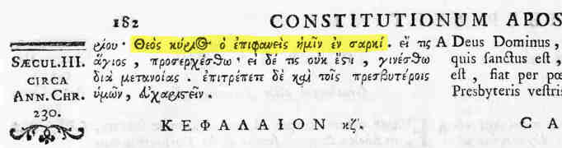
https://archive.org/details/gri_33125011194236/page/n245
Θεὸς Κύριος ὁ ἐπιφανεὶς ἡμῖν ἐν σαρκί.
[The] Lord God who appeared to us in [the] flesh

(f) Basil the Great, 4th century, [Burgon-RR, p. 464] - verified
The reference can be found online in volume 4, page 76 of the 1934 edition of Saint Basil, The Letters in the Loeb Classical Library, with Greek and an English Translation by Joseph Deferrari and Martin R. P. McGuire. Digitizing sponsor: Andrew W. Mellon Foundation. Image for personal use only.
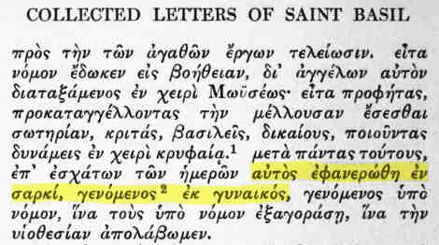
https://archive.org/details/letterswithengli04basiuoft/page/76
αὐτὸς ἐφανερώθη ἐν σαρκί, γενόμενος ἐκ γυναικός
He Himself was made manifest in the flesh, “made of a woman ....”

This reference can be also verified in English only from Nicene and Post-Nicene Fathers of the Christian Church, volume 8, translated by Rev. Blomfield Jackson, on page 300, Epistle CCLX1 (261).
https://archive.org/details/selectlibraryofn08schauoft/page/300
He was Himself manifested in the flesh, “made of a woman ....”

The Patristic Witnesses, on “terra firma”, summarized on pages 485 - 490 of [Burgon-RR]

We also briefly mention the “versions” (ancient translations) and “Copies” (continuous Bible text manuscripts – though some are “catenas”, i.e. with interspersed commentary, and sometimes a loose form of the main text itself). This enables us to retain Burgon's numbering.

- Dionysius of Alexandria, 3rd century, [Burgon-RR, p. 461] - verified
This reference is found online on www.archive.org in volume I, printed column 853, line 44, of our reference [Concilia]. Digitizing Sponsor: Getty Research Institute. Image for personal use only.
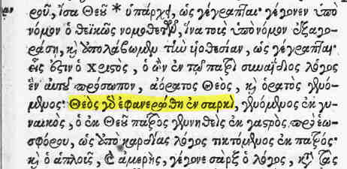
https://archive.org/details/gri_33125010892426/page/n439
θεὸς γὰρ ἐφανερώθη ἐν σαρκί
For God was manifested in [the] flesh

- Didymus (of Alexandria, the Blind), 4th century, [Burgon-RR, p. 456] - verified
Burgon's reference De Trin. p. 83 refers to a paragraph, or pericope, number, not a page number. The book is De Trinitate (Concerning the Trinity). The citation be verified in volume 39, column 403, of our reference [PatrGraec]. Digitizing sponsor: Google. Image for personal use only.
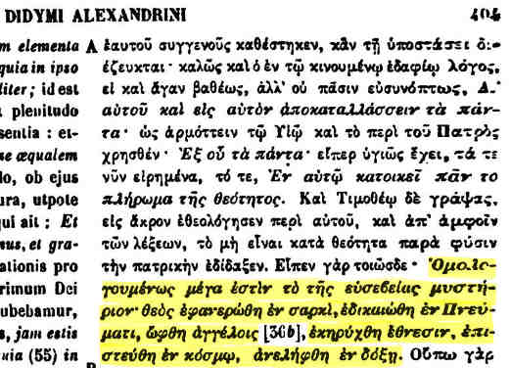
https://archive.org/stream/PatrologiaGraeca/Patrologia%20Graeca%20Vol.%20039#page/n227/mode/2up
The citation is 1 Timothy 3:16 in full. Remark: We notice further down the same column the traditional reading of Luke 2:14.
Δόξα ἐν ὑψίστοις θεῷ, καὶ ἐπὶ γῆς εἰρήνη· ἐν ἀνθρώποις εὐδοκία.
“Glory in the highest realms to God,
And peace on earth;
Goodwill among men.”

- Gregory, Bishop of Nazianzus, 4th century, [Burgon-RR, p. 457] - verified
Burgon's reference on page 357 reads i. 215 a: 685 b. Assuming Burgon used [PatrGraec], Patrologia Graeca, this should read i. 215 a: ii. 685 b. The volumes are 35 and 36 of Patrologia Graeca, and the numbers refer to paragraph, or pericope, numbers, not column or page numbers. The printed column number is 785, near where the number 215 can be seen in the Latin. Digitizing sponsor: Google. Images for personal use only.
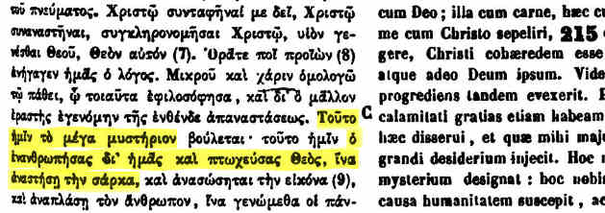
https://archive.org/stream/PatrologiaGraeca/Patrologia%20Graeca%20Vol.%20035#page/n415/mode/2up

The other reference is column 348, at the end:
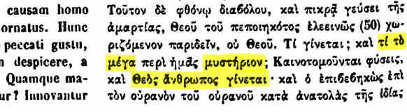
https://archive.org/stream/PatrologiaGraeca/Patrologia%20Graeca%20Vol.%20036#page/n183/mode/2up
And what is the great mystery ...? God became a man.

(4) Diodorus of Tarsus, 4th century, [Burgon-RR, p. 459] - verified
The reference is to J. A. Cramer's Catenae, our reference [Cramer] volume 4, In Epistolam ad Romanos, page 124, line 8. Digitizing sponsor Google. Image for personal use only.
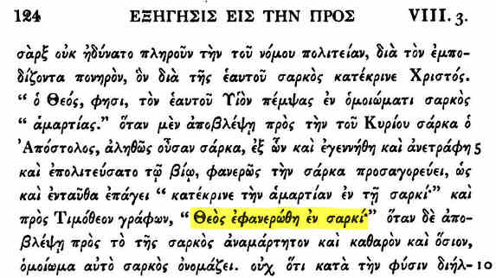
https://archive.org/stream/CatenaeGraecorumPatrumchainOfGreekFathersOnNewTestament/04.CatenGraecPatr.NT.Rom.v4.Cramer.1844.#page/n131/mode/2up
It can also be seen from digitizing sponsor University of Toronto.
https://archive.org/details/catenaegraecorum04cramuoft/page/124

(5) Gregory of Nyssa in Cappadocia, 4th century, [Burgon-RR, p. 101, p. 456] - verified
Burgon's Gallandi references on page 456 are page numbers in volume vi of [Gallandi], with paragraph letters which appear in the middle margin. We have not identified the other references, which don't seem to be from [PatrGraec] or [Gallandi] or Franz Oehler's S. Gregorii Episcopi Nysseni opera (either on a page or pericope numbering scheme). Burgon gives several Gallandi references. We give the one on page 526, at section D. Digitizing sponsor: Getty Research Institute. Image for personal use only.
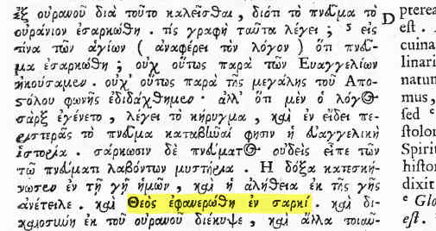
https://archive.org/details/gri_33125011194418/page/n545

(6) John Chrysostom (Archbishop of Constantinople), 4th century, [Burgon-RR, p. 457] - an example verified
We have found the text of Burgon's reference (on page 457) to de Beato Philogonio, but only because he specifies the passage by name. We cannot match his abbreviated references, (i. 497 c d e.–viii. 85 e : 86 a.–xi. 605 f : 606 a b d e) to any Greek edition of Chrysostom we have found online, and we have found several. Clearly, Burgon's source must have at least 11 volumes. We have found:
- Sir Henry Saville, Tou en hagious ... Chrysostomou, Eton, 1613, in 8 volumes. Page 497 does not contain de Beato Philogonio; it contains Εἰς τὴν γένεσιν.
https://archive.org/details/SavileChrysostom1/page/n497
- [Gallandi] volume 8 contains Chrysostom, but Burgon is not referring to this.
https://archive.org/details/gri_33125011194533/page/n127
- An edition by Bernard de Montfaucon, dated 1836, containing de Beato Philogonio on page 609. See below.
- An edition by Bernard de Montfaucon, dated 1862, containing de Beato Philogonio in column 753. See below.

A Google search for Montfaucon Chrysostom de Beato Philogonio finds the text. It is Tomus Primus, Pars Altera (First volume, part 2 of 2) of a Bernard de Montfaucon edition, dated 1836. It is not the earliest edition, as it has been emended and augmented (editio ... emendata et aucta). The reference is on page 609. Digitizing sponsor Google. Image for personal use only.
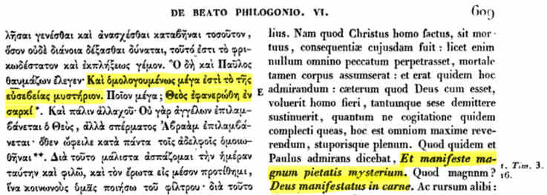
https://books.google.co.uk/books?id=r8sGAAAAQAAJ&pg=PA609#v=onepage&q&f=false

The same passage can be found in the 1862 edition of Montfaucon, Tomi primi pars posterior (Latter part of the first volume), with different typesetting, at column 753, line 15. The link below is to volume 8 of the [PatrGraec] series, which incorporates Montfaucon.
https://archive.org/stream/PatrologiaGraeca/PatrologiaGraecaVol.048#page/n231/mode/2up/search/ORDO

We surmise that Burgon had yet another Montfaucon edition, and considering it to be the obvious reference to Chrysostom, thought it unnecessary to give details in his references.

(7) Περὶ θείας σαρκώσεως (Concerning Divine Incarnation), 4th century [Burgon-RR, pp. 457-8] - verified
This is a section title attributed to Euthalius (Burgon, p. 458). Burgon references a footnote on page 59 of Scrivener's Plain Introduction, for the attribution to Euthalius, and for this Scrivener's second edition (1874) is required. Digitizing sponsor: Internet Archive. Image for personal use only.
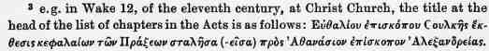
https://archive.org/details/plainintroduct00scri/page/58
The original of this can be seen on the INTF website, if you have access to restricted manuscripts. Wake 12 is GA 506, so the INTF ID is 30506, and the image required is 2590.
http://ntvmr.uni-muenster.de/manuscript-workspace.
IMAGE NOT INCLUDED TO ENSURE NO VIOLATION OF CONDITIONS

The titles of 1 Timothy are in the writings of Euthalius [PatrGraec], volume 85, column 781. Digitizing sponsor: Google. Image for personal use only.
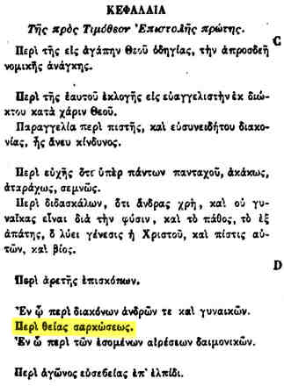
https://archive.org/stream/PatrologiaGraeca/Patrologia%20Graeca%20Vol.%20085#page/n389/mode/2up.

We can easily verify the title Περὶ θείας σαρκώσεως in the manuscripts as it is frequent, and in GA 181 (Vatican Reg Gr 179) it is in the list of sections. It is at image 2940.
http://ntvmr.uni-muenster.de/manuscript-workspace. This manuscript has restricted access.
IMAGE NOT INCLUDED TO ENSURE NO VIOLATION OF CONDITIONS

The title Περὶ θείας σαρκώσεως is even present in 3 manuscripts reading ὅς. Here are the GA numbers and INTF image numbers:
- GA 91, Doc ID 30091, image 4940, at top of page.
- GA 463, Doc ID 30463, image 4050, at bottom of column 1.
- GA 1175, Doc ID 31175, image 3930, at bottom of column 1.
The presence of περὶ θείας σαρκώσεως (or, misspelt, σαρκόσεως) renders the testimony of these manuscripts somewhat ambiguous.
http://ntvmr.uni-muenster.de/manuscript-workspace. ID 31175 is not restricted.
IMAGE NOT INCLUDED TO ENSURE NO VIOLATION OF CONDITIONS

(8) Codex Alexandrinus, (A, GA 02), 5th century, [Burgon-RR, pp. 431-437] - mostly verified, and certainly substantiating the original reading as Θ̅Ϲ̅, (God)
We cover this in detail in a separate study, [FAA-A], which is
http://www.faraboveall.com/015_Textual/1Tim_3_16_Alexandrinus.pdf. But here is a summary. The issue revolves around the original line (before another was added) in the theta, Θ, in the word ΘϹ, which is the abbreviated form of ΘΕΟϹ, God. Without the line, one would read OϹ, he, and lose the force of the verse. The following early (mainly 17th century) collators or observers saw the old line only Patrick Young, Alexander Huish, Bishop John Pearson, Bishop John Fell, Dr John Mill (who remarked that it was becoming faint). No-one pre-the-new-line collated OϹ. Then, perhaps in 1716, the new line was added, but not entirely obscuring the old line, and the following saw remnants of the old line: John Creyk, William Wotton, John James Wetstein (who later changed his mind), John Berriman, Johann Albrecht Bengel, Karl Gottfried Woide, two Gentleman accompanying Berriman. Our main verification document is [Berriman], but see our study for many others. Opponents to the reading base their counter-evidence to all these testimonies on the presence of an epsilon on the other side of the page, Bishop Ellicott amongst them in about 1881 pronouncing his conclusion indisputable. Burgon calls this “inconveniently bordering on the ridiculous”.

(9) Cyril of Alexandria, 5th century, [Burgon-RR, p. 464] - verified
Burgon's reference Opp. V. Part 2, p. 124 c d must refer to some standard edition of Cyril which we have not found online, but the same text is available in volume 76 of [PatrGraec], column 1332. Digitizing sponsor: Google. Image for personal use only.
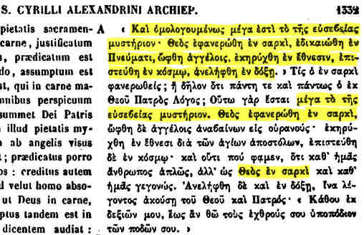
https://archive.org/stream/PatrologiaGraeca/Patrologia%20Graeca%20Vol.%20076#page/n713

From [Concilia] volume 3, column 221, we see the same text, as observed by Burgon. The introduction, in column 2, mentions “Cyril, a wise and holy bishop, roaring against his adversaries”. Digitizing sponsor: Getty Research Institute. Image for personal use only.
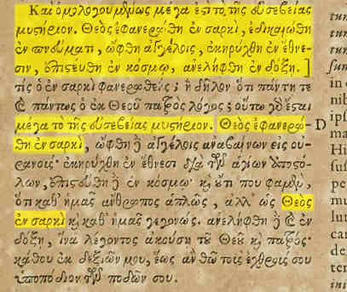
https://archive.org/details/gri_33125010892988/page/n119

(10) Theodoret, Bishop of Cyrus in Syria, 5th century, [Burgon-RR, p. 456-7] - verified
The references are in Patrologia Graeca, our reference [PatrGraec]. Digitizing sponsor: Google. Images for personal use only.

First reference, i. 92. From Patrologia Graeca, volume 80, column 192. This is Quaest(io) in Genes(in), chapter 29. 1 Timothy 3:16 is quoted with intervening commentary.
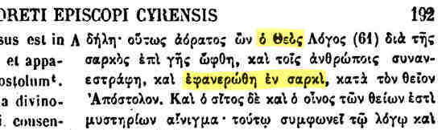
https://archive.org/stream/PatrologiaGraeca/Patrologia%20Graeca%20Vol.%20080#page/n103/mode/2up

Second reference, iii. 657. From Patrologia Graeca, volume 82, column 809, line 46. This is Interpretatio Epist(ulae) I Ad Tim(otheum) Cap(ut) III. 1 Timothy 3:16 is quoted.
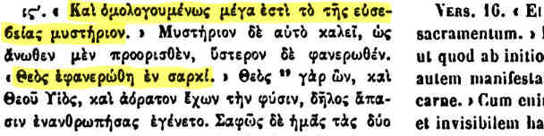
https://archive.org/stream/PatrologiaGraeca/Patrologia%20Graeca%20Vol.%20082#page/n425/mode/2up

Third reference, iv. 19. From Patrologia Graeca, volume 83, column 48, line 19. This is Dialogus I Inmutabilis. 1 Timothy 3:16 is quoted in full.
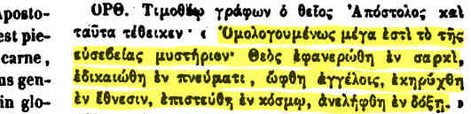
https://archive.org/stream/PatrologiaGraeca/Patrologia%20Graeca%20Vol.%20083#page/n29/mode/2up

Fourth reference, iv. 23. From Patrologia Graeca, volume 83, column 52, line 15. This is Dialogus I Inmutabilis. The relevant part of 1 Timothy 3:16 is quoted.
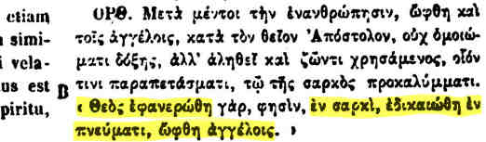
https://archive.org/stream/PatrologiaGraeca/Patrologia%20Graeca%20Vol.%20083#page/n31/mode/2up

(11) The Anonymous Author of 430 A.D. [Burgon-RR, p. 475] - verified
Although we have not identified Burgon's reference on page 475, Apud Athanasium, Opp. ii. 33, we have found what is probably his reference text in [PatrGraec], volume 4, column 89, at the bottom. Digitizing sponsor: Google. Image for personal use only.
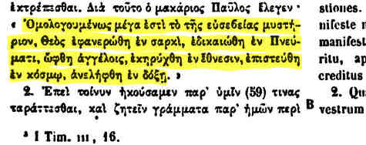
https://archive.org/stream/PatrologiaGraeca/Patrologia%20Graeca%20Vol.%20028#page/n49/mode/2up

The same edition is also available at
https://books.google.co.uk/books?id=5r0UAAAAQAAJ&printsec=frontcover&source=gbs_ge_summary_r&cad=0#v=onepage&q=I%20Tim&f=false.

(12) Euthalius, Bishop of Sulca, 5th century, [Burgon-RR, p. 459-461] - verified
The discussion above (7) Περὶ θείας σαρκώσεως (Concerning Divine Incarnation) covers both the manuscript presence of the title and the attribution to Euthalius.

(13) Macedonius II, Patriarch of Constantinople, 5th century, [Burgon-RR, pp. 470 - 475] - verified
Burgon's account, from Liberatus the Deacon, can be verified in [Gallandi], volume 12, pages 152-153. We have joined the column change with a short gap in our image below. Digitizing sponsor: Getty Research Institute. Image for personal use only.
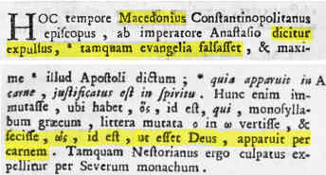
https://archive.org/details/gri_33125008697738/page/n195
Highlighted text: Macedonius ... is said to have been deposed as having falsified the gospels ... and to have made ὡς (hōs, not hŏs), so that it was God; he appeared by means of flesh.

Now ὡς means as or because, so the story as it stands is inconsistent (Burgon: “very lame”). And even if the rumour is to be taken seriously, then it must be conceded that Macedonius is a witness to God was manifest in the flesh. But Burgon has an excellent explanation which makes sense of Liberatus: the text also contained Deus, and Macedonius was actually accused of changing Deus qui into Deus quia, i.e. ὃς θεὸς into ὡς θεὸς, so Macedonius read God was manifested in the flesh all along!

(14) Georgian Version, 5th or 6th century, [Burgon-RR, p. 454] - attested by the Georgian Church, and inferred to be true.
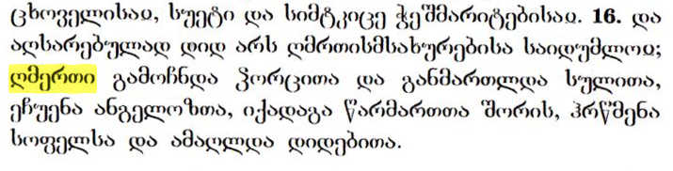
Burgon, informed by Dr Malan, informs us that the Georgian version unequivocally witnesses to Θεός, God. The dean of the Orthodox Georgian Church in London, Father Dorote Barbakadze, informs the present author that this is indeed the traditional reading dating from the earliest times, and it is the reading in the Bible used in the Georgian Church.
The word for God is highlighted.

(15) Severus, Bishop of Antioch, 6th century, [Burgon-RR, p. 458] - verified
Burgon's reference, Cramer's Cat. in Actus, iii. 69 refers to John Antony Cramer's Catenae Graecorum Patrum in Novum Testamentum, Oxford, 1844, Tomus (Volume) 3, In Acta SS. Apostolorum (On the Acts of the Holy Apostles), section 3, page 69, at the top. Digitizing sponsor: Google. Image for personal use only.
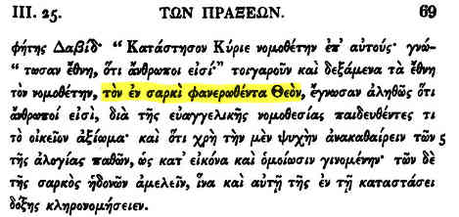
https://archive.org/stream/CatenaeGraecorumPatrumchainOfGreekFathersOnNewTestament/03.catengraecpatr.Nt.act.v3.cramer.1844.#page/n89/mode/2up
Literally: The in flesh having-appeared God

(16) Harkleian Syriac Version, 616 A.D., [Burgon-RR, p. 450] - verified
We cover this in detail in a separate study, [FAA-Hk], which is
http://www.faraboveall.com/015_Textual/1Tim_3_16_Harklean.pdf. But here is a summary using English only. There is a Greek word meaning piety which occurs 15 times in the New Testament. In the Harklean Syriac it has the literal translation beauty-of-fear 14 times, and just fear once. One of the 14 cases is 1 Timothy 3:16, where the word piety / beauty-of-fear is followed by God in Greek, and by God in the Harkleian Syriac. Yet there are, or were, critics who claim that the word God is to be disallowed in translating the Harklean in 1 Timothy 3:16, because of an apparent rule that if the verse is 1 Tim 3:16 – and this verse only – then the Syriac for piety changes from beauty-of-fear to beauty-of-fear-of-God, with the result that God is eliminated in the English of the Harklean – swallowed up in the word piety. Readers must assess the fairness of this for themselves. We simply present the issue in a factual way, by presenting the Greek and Syriac of the relevant verses.

(17) John Damascene, 8th century, [Burgon-RR, p. 457] - verified
Burgon's references, i. 313, and ii. 263, were hard to find, as they are not in [PatrGraec] or [Gallandi], and we could not find the very old printed editions (e.g. that of 1603), online, nor could we find the text itself in a multitude of Latin and English editions. But we found the references in the end, thanks to the (Dutch language) University of Gent website, in Ιωάννου τοῦ Δαμασκήνου, Joannis Damasceni, Paris, 1712, volume 1, page 313, section D. Digitizing sponsor: Google. Image for personal use only.
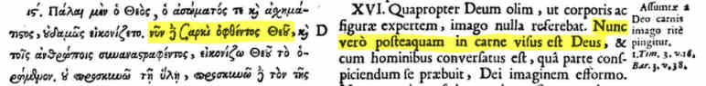
https://books.google.be/books?vid=GENT900000211174
The highlighted Greek text reads νῦν δὲ σαρκὶ ὀφθέντος Θεοῦ, (but now, God having appeared in [the] flesh). The second reference, from volume 2, page 263, near the top of the left-hand column, quotes the key part of 1 Timothy 3:16 word for word. Digitizing sponsor: Google. Image for personal use only.
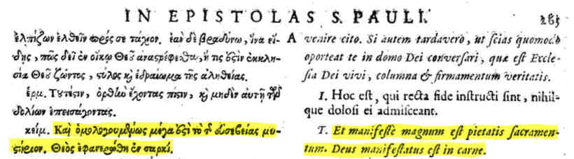
https://books.google.be/books?vid=GENT900000211175

(18) Epiphanius, Deacon of Catana, 8th century, [Burgon-RR, p. 475] - verified
This reference is found in the Sacrosancta Concilia, our reference [Concilia], volume 7, column 618, section E. Digitizing sponsor: Getty Research Institute. Image for personal use only.
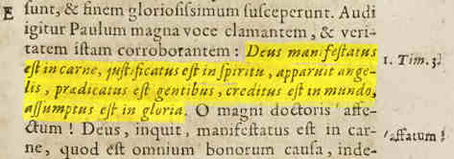
https://archive.org/details/gri_33125010892541/page/n319
1 Timothy 3:16 is quoted from God was manifested in the flesh, highlighted.

(19) Theodorus Studita, 8th century, [Burgon-RR, p. 475-6] - verified
Burgon's reference is to Theodori Studitae Epsitolae, Pars II, 36 and 156. We did not find a scan of this book on the internet. But the same content is in [PatrGraec], volume 99, columns 1215-6 and 1487-8, where we have included the Latin column. The Greek in the scan of the second reference is partly missing, but it the scan shows our text. Digitizing sponsor: Google. Images for personal use only.
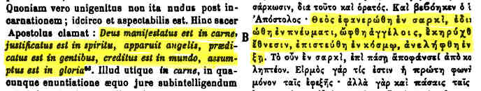
https://archive.org/stream/PatrologiaGraeca/Patrologia%20Graeca%20Vol.%20099#page/n609/mode/2up

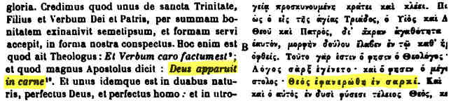
https://archive.org/stream/PatrologiaGraeca/Patrologia%20Graeca%20Vol.%20099#page/n743/mode/2up

(20) Codex K (Mosquensis, GA 018), 9th century, [Burgon-RR, p. 490] - verified
INTF ID/image/column/line 20018/5640/2/16
http://ntvmr.uni-muenster.de/manuscript-workspace
IMAGE NOT INCLUDED TO ENSURE NO VIOLATION OF CONDITIONS
See almost all manuscript readings of 1 Timothy 3:16 here.
http://www.faraboveall.com/015_Textual/1Tim_3_16_Spreadsheet.pdf

(21) Codex L (Angelicus, GA 020), 9th century, [Burgon-RR, p. 490] - verified
INTF ID/image/line 20020/3260/20 (-7)
http://ntvmr.uni-muenster.de/manuscript-workspace
IMAGE NOT INCLUDED TO ENSURE NO VIOLATION OF CONDITIONS
See almost all manuscript readings of 1 Timothy 3:16 here.
http://www.faraboveall.com/015_Textual/1Tim_3_16_Spreadsheet.pdf

(22) Codex P (Porphyrianus, GA 025), 9th century, [Burgon-RR, p. 490] - corroborated
INTF image unavailable, but Wikipedia attests the reading:
“In 1 Timothy 3:16 it has textual variant θεός ἐφανερώθη”
https://en.wikipedia.org/wiki/Codex_Porphyrianus

(23) The Slavonic version, 9th century, [Burgon-RR, p. 454] - corroborated
Not verified against a manuscript, but (1) the word for God is admitted by Bishop Ellicott (as reported by Burgon, [Burgon-RR, p. 429]), (2) the word for God is the form given in a printed edition, (Nóvíi Zavet, New York, 1867), scanned from the copy in The Massachusetts Bible Society Library, catalog number A412.2-1867, page 529 on the left, where 1 Timothy 3:16 ends. Digitizing sponsor: Boston Library Consortium Member Libraries. Image for personal use only.
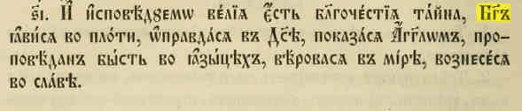
https://archive.org/details/nvizavetgdan00amer/page/n1061
We have highlighted the word for God.

(24) Several ancient scholia, 9th century, [Burgon-RR, p. 476] - part verified
The images are held here (some with restricted access):
http://ntvmr.uni-muenster.de/manuscript-workspace
IMAGES NOT INCLUDED TO ENSURE NO VIOLATION OF CONDITIONS
- Paul 113 (GA 101), a manuscript held in Dresden, damaged in WW2, and partly illegible (from the scans, at least). The scriptural reading is probably at INTF ID/image/column/line 30101/950/2/somewhere. The scholia are probably in the margin of the same page.
- Paul 115 (GA 103). Two scholia verified. The scriptural reading is at INTF 4730/16 (-4). The first scholium reads θεὸς ἐσαρκώθη (God became flesh), at INTF ID/image/line 30103/4730/margin/45 (-19). The second scholium reads θεὸς ἐφανερώθη πῶς, ἐν σαρκί (God appeared - how? - in flesh) at INTF ID/image/line 30103/4730/margin/52 (-12).
- Paul 118 (GA 463). This is one of the very few manuscripts which reads ὃς ἐφανερώθη ἐν σαρκί, (at ID/image/line/4050/1/15) but not μυστήριον ὃς, for this is a catena – not a continuous-scriptural text. There are 13 lines of commentary between μυστήριον and ὃς ἐφανερώθη, the latter part of the intervention being ὂς ἁμαρτίαν οὐκ ἐποίησεν, οὐδὲ ἐρέθη δόλος ἐν τῷ στόματι αὐτοῦ, from Isaiah 53:9. The text appears to be just Oecumenius, as in GA 1927 q.v. below.
- Paul 123 (GA 1927). We think Scrivener's Moscow Syn. 099 should be Syn. 098, Diktyon 43723, as this matches the properties: 241 folios, 10th century, and commentary. Moscow Synod gr. 099 is not in the INTF Liste; also, it is Diktyon 43724, which is not tagged on [Pinakes] with an Aland identifier. GA 1927 has 1 Timothy 3:16 at INTF 31927/3730/main-text/1, reading θεὸς. The foot of INTF 31927/3720 has a section title Περὶ θείας σαρκώσεως (Concerning divine incarnation). But the commentary, which according to
https://pinakes.irht.cnrs.fr/notices/cote/43723/
is Oecumenius, at INTF 31927/3730/commentary-text/5, reads ὃς ἐφανερώθη ἐν σαρκί, but not μυστήριον ὃς, following ὂς ἁμαρτίαν οὐκ ἐποίησεν, οὐδὲ ἐρέθη δόλος ἐν τῷ στόματι αὐτοῦ, from Isaiah 53:9, as in GA 463, q.v. above.

(25) Oecumenius, 10th century, [Burgon-RR, p. 476] - verified
We found Burgon's reference ii. 228 a in Oecumenii Opera et Arethae in Apocalypsin Tomus II Graec. Lat., ... Lutetiae Parisiorum, 1801, page 228, near the top. Digitizing sponsor: Google. Image for personal use only.
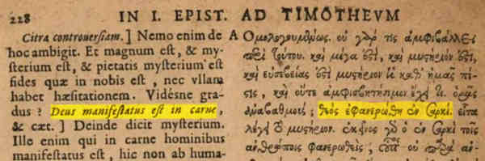
https://archive.org/details/bub_gb_J9D8qw-kYBkC/page/n251

(26) Theophylact (of Ohrid, then in Bulgaria), 11th century, [Burgon-RR, p. 476] - verified
Burgon's references are ii. 569 e and 570 a. We cannot find this volume online. It may have been an edition that was published by J. F. B. M. de Rossi (4 vols. fol., Venice). These volumes were republished in [PatrGraec], volumes 123-126, but Burgon's page or column numbers do not match. Nevertheless we have found what must be Burgon's text in volume 125 of [PatrGraec], column 49, near the bottom. Digitizing sponsor: Google. Image for personal use only.
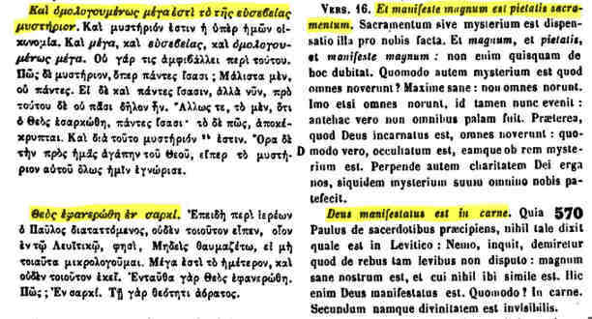
https://archive.org/stream/PatrologiaGraeca/Patrologia%20Graeca%20Vol.%20125#page/n27/mode/2up

We also found a Latin edition by Christophoro Porsena Romano interprete, Theophylacti archiepiscopi Bulgariae, March 1532, page 708, but it uses the Vulgate, not a translation of the Greek. However, it still gives a witness to the incarnation of God. Digitizing sponsor: Google. Image for personal use only.
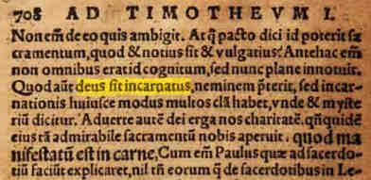
https://archive.org/details/bub_gb_hWURIDp4gf4C/page/n723
Highlighted text: God became incarnated. The bolder, larger text is the Vulgate reading, which was manifested in flesh.

Another edition of the same text by the same translator (Cristophus Porsenus) is an edition dated, 1542. The text is on the verso of folio CXXVI, opposite folio CXXVII, 10 lines from the bottom of the page. Digitizing sponsor: Google. Image for personal use only.
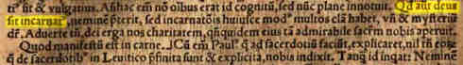
https://archive.org/details/bub_gb_VSCWS3zZ2xsC/page/n267

(27) Euthymius, 12th century, [Burgon-RR, p. 476] - verified
Burgon's reference is to a Greek book, Εὐθύμιος Ζιγαβηνός. Πανοπλία Δογματικὴ Ἀλεξίου Βασιλέως τοῦ Κομνηνοῦ περιέχουσα ἐν συνόψει τὰ τοῖς... πατράσι συγγραφέντα..., Τεργόβιστε Οὐγγροβλαχίας, Μάιος 1710. Access this page
http://www.onassislibrary.gr/en/collection/items/37901_en/
then load the book and, navigate to the page following the one numbered ρκγ' (for the verso). 1 Tim 3:16 is in column 1. Provided by Onassis Library. Image for personal use only.
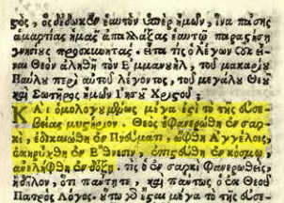
http://www.onassislibrary.gr/uploads/mediaem/documents/00981.pdf
1 Timothy 3:16 highlighted.

Additional testimonies adduced by the present author

Codex C, 5th century.
Burgon placed this on ambivalent territory, but we have sufficient evidence the line in the theta is original, and that the manuscript reads Θεός. We have a detailed study of this here:
http://www.faraboveall.com/015_Textual/CodexC_1T316.pdf

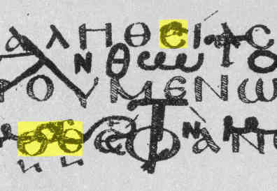
The image below is taken from Tischendorf's facsimile of the manuscript, as reproduced in [Scrivener-PI], showing the contested word Θ̅Ϲ̅ . The manuscript has been spoiled since, probably by much touching, and perhaps by the application of chemicals, and is less clear at this place.

We claim that the line in the theta of Θ̅Ϲ̅ is original. It is very similar to the sagitta of the highlighted epsilon of ΑΛΗΘΕΙΑϹ above, in the way it is thin and rising. Not many lines in thetas or sagittas of epsilons are like this, but some are, and Tischendorf's claim that the contested line is secondary because it slopes upwards, is clearly refuted. Tischendorf gave one other reason: the line is faint. But the whole text is faint, especially the thinner lines, because the manuscript is a palimpsest, meaning that the biblical writing has largely been scrubbed off so that the parchment could be used for something else – St. Ephraim the Syrian [Scrivener-PI, vol. I, p. 121]. So there is no reason to suspect a correction to this manuscript here. For Tischendorf's claims (in Latin – subnigra est – a sinistra adscendit), see page 41, lines 28 and 29, of his Codex Ephraemi Syri Rescriptus.
https://books.google.co.uk/books?id=JrYhAQAAMAAJ&pg=RA2-PA41&lpg=RA2-PA41

Andreas of Crete, 7th century
He was born at Damascus about 635. We found a reference in [Gallandi], volume 13, page 96, lines 16-17. Digitizing sponsor: Getty Research Institute. Images for personal use only.
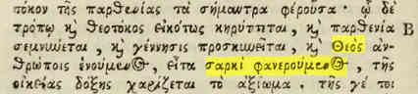
https://archive.org/details/gri_33125008697795/page/n121

The Minuscules.
We have examined all the INTF scans of the minuscules containing 1 Timothy 3:16. Almost all manuscripts have been scanned, so we have an almost complete picture. For where to find the reading on each manuscript, and the results, see the spreadsheet which is linked to here:
http://www.faraboveall.com/015_Textual/01_Textual.html

The following picture, from our study Scripture, Authentic and Fabricated, shows the balance of manuscript evidence. The study is linked to on http://www.faraboveall.com/015_Textual/01_Textual.html

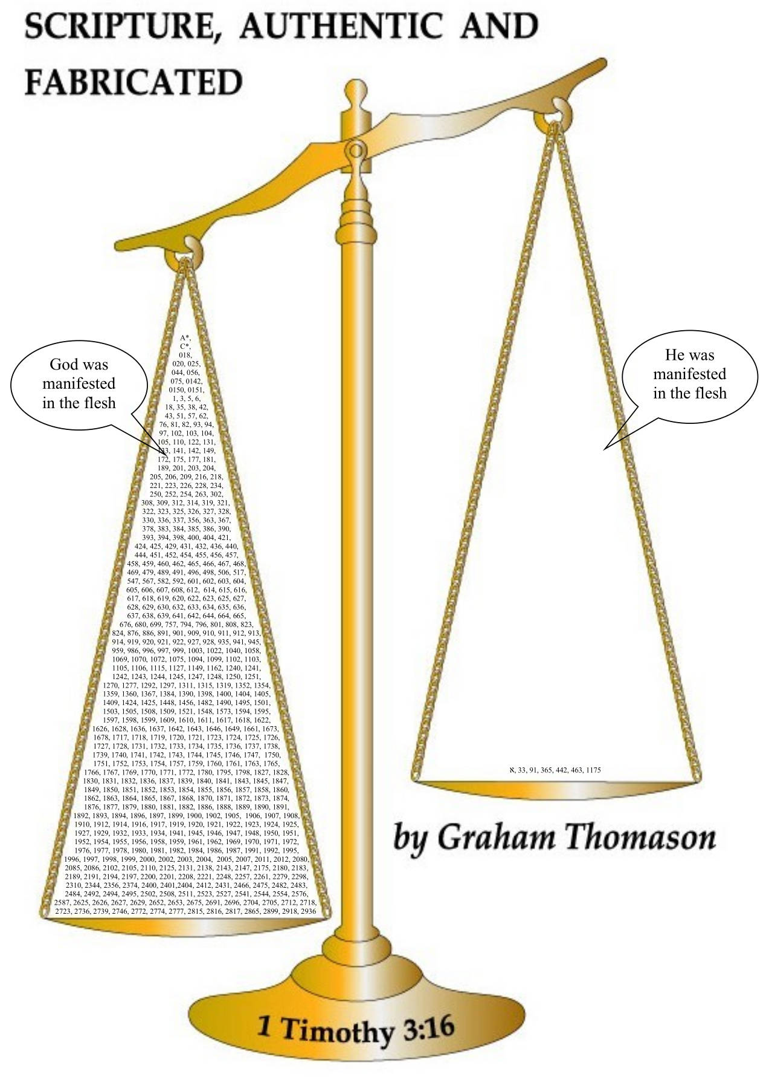
The Lectionaries
Only a fraction of the lectionaries have been scanned by INTF, but 61 containing 1 Timothy 3:16 have [as of February, 2019], and the locations and results are given in the link below. Of the 61, 59 read plain θεός, 1 reads θεοῦ, and 1 reads ὅς. The study is linked to on
http://www.faraboveall.com/015_Textual/01_Textual.html

Summary
Burgon has shown, and we have verified, that there is abundant ancient evidence for the reading God was manifested in the flesh, far outweighing the contrary evidence, and importantly, going back earlier than it.

We prefer to consider (7) Περὶ θείας σαρκώσεως and (12) Euthalius as one witness (to avoid any suggestion of double counting). Apart from manuscript evidence (AKLP above, and minuscules and lectionaries, considered in a separate study), and ancient version evidence (considered in a separate study), Burgon has supplied 6 suggestive (or, as Burgon better describes them, allusive – p. 463) patristic testimonies, and 19 firm testimonies, several of which are older than any manuscript containing 1 Timothy 3:16. We have verified almost all of them.

We have added Andreas of Crete as an allusive witness, and codex C as firm witness, and over 300 manuscripts and about 30 lectionaries unknown to Burgon.

References

References to our companion studies on www.FarAboveAll.com

[FAA-A] The Reading of 1 Timothy 3:16 in Codex Alexandrinus

http://www.faraboveall.com/015_Textual/1Tim_3_16_Alexandrinus.pdf

[FAA-C] The Reading of 1 Timothy 3:16 in Codex C, (Ephraemi Syri Rescriptus)

http://www.faraboveall.com/015_Textual/CodexC_1T316.pdf

[FAA-FG] The Reading of 1 Timothy 3:16 in Codices F and G

http://www.faraboveall.com/015_Textual/1Tim_3_16_FG.pdf

[FAA-Hk] The Reading of the 1 Timothy 3:16 in Harklean Syriac Version

http://www.faraboveall.com/015_Textual/1Tim_3_16_Harklean.pdf

[FAA-Ms] The reading of 1 Timothy 3:16 in the New Testament Manuscripts
http://www.faraboveall.com/015_Textual/1Tim_3_16_Spreadsheet.pdf

[FAA-Lc] The reading of 1 Timothy 3:16 in the Lectionaries

http://www.faraboveall.com/015_Textual/1Tim_3_16_Lectionaries.pdf

Major editions of patristic works

[Concilia] Sacrosancta Concilia, edited by Philippe Labbe and Gabriel Cossart, published in 1678. N.B. The whole set of Sacrosancta Concilia consists of 15 large volumes (volume 1 containing 1572 pages). Search for Sacrosancta Concilia on

www.archive.org.

Example: https://archive.org/details/gri_33125010892426/page/n439

Digitizing Sponsor: Getty Research Institute.

[Cramer] J. A. Cramer, Catenae Graecorum Patrum, in 8 volumes, Oxford 1844. Search www.archive.org for Cramer Catenae. The start of the catena on Romans is at

https://archive.org/details/catenaegraecorum04cramuoft/page/n4.

Digitizing sponsor: University of Toronto.

[Gallandi] Andreas Gallandi, Bibliotheca veterum patrum antiquorumque scriptorum ecclesiasticorum, Venice, 1765-1781. The 14 volumes, covering 380 writers, of patristic texts can be found individually by searching for Gallandi Bibliotheca on www.archive.org.

For example, volume 4 is https://archive.org/details/gri_33125011194236/page/n245.

For an index, see

https://archive.org/details/bub_gb_dTtm8uifaKYC/page/n29,
but there are better indexes in each volume. Digitizing sponsor: Getty Research Institute.

[Loeb] Early, out of copyright (but check each case), editions of the Loeb Classical Library, can be found by searching for Loeb Classical on the www.archive.org site. The library includes many patristic authors with an English translation.

[PatrGraec] https://archive.org/details/PatrologiaGraeca
Patrologia Graeca. These are 161 volumes of patristic texts, prepared by J.-P. Migne. For example, volume 83 of the whole series is volume 4 of the series on Theodoret, with the title TRADITIO CATHOLICA, SAECULUM V, ANNUS 458, ΘΕΟΔΩΡΕΤΟΥ ΕΠΙΣΚΟΠΟΥ ΚΥΡΟΥ ΑΠΑΝΤΑ, THEODORETI CYRENSIS EPISCOPI, OPERA OMNIA, POST RECENSIONEM JACOBI SIRMONDI, EDIDIT ... JOAN. LUDOV. SCHULZE, ... ACCURANTE DENUO RECOGNOSCENTE J.-P. MIGNE ... 1864. The Father / chapter / section title is Theodoreti Episcopi Cyrensis / Dialogus II Inconfusus / Sancti Hippolyti episcopi et martyrus. Burgon's “Opp. iv. 132” is to be read as Opera Omnia (all works, as in the title above), volume 4, passage 132. “Opensource Collection”. Digitizing sponsor: Google.

See also the links at http://patristica.net/graeca/.

Other references

[Barnabas-L] Barnabas, Epistle of Barnabas in The Apostolic Fathers II, Loeb Classical Library, LCL 25. Edited and translated by Bart D. Ehrman. Harvard University Press, ISBN 0-674-99608-9.

[Berriman] John Berriman, ΘΕΟΣ ἐφανερώθη ἐν σαρκί, or, A Critical Dissertation upon 1 TIM iii. 16, London. 1741. See especially pages 153-156.
https://books.google.co.uk/books?id=OJxhAAAAcAAJ.

CSNTM The Center for the Study of New Testament Manuscripts. The site hosts scans of manuscripts and some books. http://www.csntm.org/

[deBoer] A earlier study, when less was available online, by Berend de Boer to verify Burgon's manuscripts. It was an inspiration for this more detailed study.

http://www.berenddeboer.net/article/1_timothy_3_16.html.

INTF http://ntvmr.uni-muenster.de/manuscript-workspace

To view a scan, select ID (not Name), and enter the ID (30091 etc.), and click on the lens, then the document found. The ID of a Gregory-Aland (GA) numbered minuscule is 3nnnn, where nnnn is the GA number with leading zeroes. But for some scans, you will see padlocks on the thumbnail images, and you will need special access (which we have been granted), but we do not reproduce any part of those here. In our companion studies, scan references are given in the format ID/image/column/line for multi-column manuscripts, and ID/image/line for single column manuscripts. A negative line number in brackets may be added for convenience, denoting the line number counting from the bottom of the page. Images in our studies are for personal use only.

[Ignatius-L] Ignatius of Antioch, Letter to the Ephesians and Letter to the Magnesians, in The Apostolic Fathers I, Loeb Classical Library, LCL 24. Edited and translated by Bart D. Ehrman. Harvard University Press, ISBN 0-674-99607-0.

[Pinakes] https://pinakes.irht.cnrs.fr/. A manuscript cataloguing site.

[Scrivener-PI] F. H. A. Scrivener, A Plain Introduction to the Criticism of the New Testament, (2 volumes), published 1894 by George Bell and Sons. There are also earlier editions.

https://archive.org/details/aplainintroducti00scriuoft

https://archive.org/details/cu31924092355118

Digitizing sponsor: MSN.

[S+W:2] Philip Schaff and Henry Wace, Nicene and Post-Nicene Fathers, Second Series. Search on www.archive.org for Schaff Wace.

Other links of interest

http://patristica.net/ – with links to scans of patristic authors.

https://www.sources-chretiennes.mom.fr/ – recent publications of patristic authors.

We retain Routh's accentuation, which is not the convention we are accustomed to (oxytone before punctuation, so Θεός, ... γεγονώς, ...).
The web page was linked to here: https://lib.ugent.be/en/catalog?q=%22Joannes+Damascenus%22&search_field=author
The earliest of the 4 manuscripts by INTF dating is GA 1927, 10th century.
Wikipedia [as of 5 April 2019] places him as early seventh century, or the late sixth century.
Wrongly catalogued on archive.org [as of 5 April 2019] as being in Russian, Basel, (Basiliensi) 1631.
Mentioned on http://www.fampeople.com/cat-theophylact-of-ohrid
https://www.biblicalcyclopedia.com/A/andreas-cretensis.html
The scales were drawn by Fiona Allison.

